Workit
Youth Recruitment Plan
Prepared for Harambee Youth Employment Accelerator / SAYouth.mobi
Furthersky Solutions · Tshepo M, Founder · 18 July 2026 · Gauteng (Phase 1)

1. Executive summary
Workit is a South African marketplace that connects households and businesses to nearby, ID-verified workers for everyday jobs — gardening, cleaning, trades, deliveries, errands, care and events. It is live at workitsa.co.za, built as a low-data app for entry-level Android phones, and it is free for workers — no registration fee, no commission, no charge of any kind to the young person.
We are asking Harambee to list Workit as an earning opportunity on SAYouth.mobi and to partner on demand-side introductions. Over 12 months in Gauteng we plan to onboard 2 000 young people (18–34) and get 1 200 of them into paid work — roughly 4 200 completed jobs and R1.68 million paid directly into young people's hands.
One honest qualifier up front: our binding constraint is employer demand, not worker supply. We currently have 72 registered workers and very few live jobs. We therefore pace worker intake to demand deliberately — recruiting thousands of young people into an empty marketplace would waste their data and their hope. Section 8 sets out the demand-side plan that earns each intake wave, and Section 11 states this as our primary risk.

2. Who we are
Legal entity | Furthersky Solutions (Reg. 2024/163230/07), South African-owned
Founder | Tshepo M — tshepowayne@workitsa.co.za
Platform | workitsa.co.za — live progressive web app (installable, works on low-end Android)
Languages | English, Afrikaans, isiZulu (Sesotho and Setswana planned)
Launch region | Gauteng, then province by province
Status | Live and operating; 79 registered accounts as at 18 July 2026

3. What the opportunity actually is
We want Harambee to be able to describe this to a young person accurately, so we state the terms plainly:
- Self-employed, flexible work — not permanent employment. Workers are independent contractors. They choose which jobs to accept, set or counter-offer their own price, and work as often as they want.
- Income is per job and variable. Observed job values on the platform run roughly R300–R800 per job depending on category and duration. A young person doing two jobs a week at R400 earns about R3 200 a month. We do not promise a salary and ask that no partner materially implies one.
- Payment is direct, in cash or EFT, between the employer and the worker. Workit does not hold or move money and takes no cut. Both sides confirm the payment in-app, which builds the worker's verifiable payment record.
- No fees to workers, ever. Registration, verification, job alerts and the app are free. Any future revenue comes from the employer side.
- No UIF or COIDA cover attaches to this work, and workers are responsible for their own tax affairs. This is disclosed in our Terms and we repeat it during onboarding.

4. Why this fits the Harambee mandate
- It reaches young people with no formal work history. Workit requires no CV, no matric certificate, no prior experience and no reference. A verified ID and a willingness to work is the entry requirement — the barrier that excludes most of Harambee's cohort simply is not there.
- It builds a track record that transfers. Every completed job accumulates ratings and a confirmed payment history into a shareable, employer-verifiable Work Record — a proof-of-work and proof-of-income certificate a young person can show a landlord, a lender, or a future employer. Informal work becomes documented work history.
- It is already youth-weighted. 58% of our current workers are 18–34, with a median age of 32 — without any youth-specific targeting yet.
- It works on the phones young people actually have. Low-data progressive web app, installable, designed for entry-level Android and intermittent connectivity.
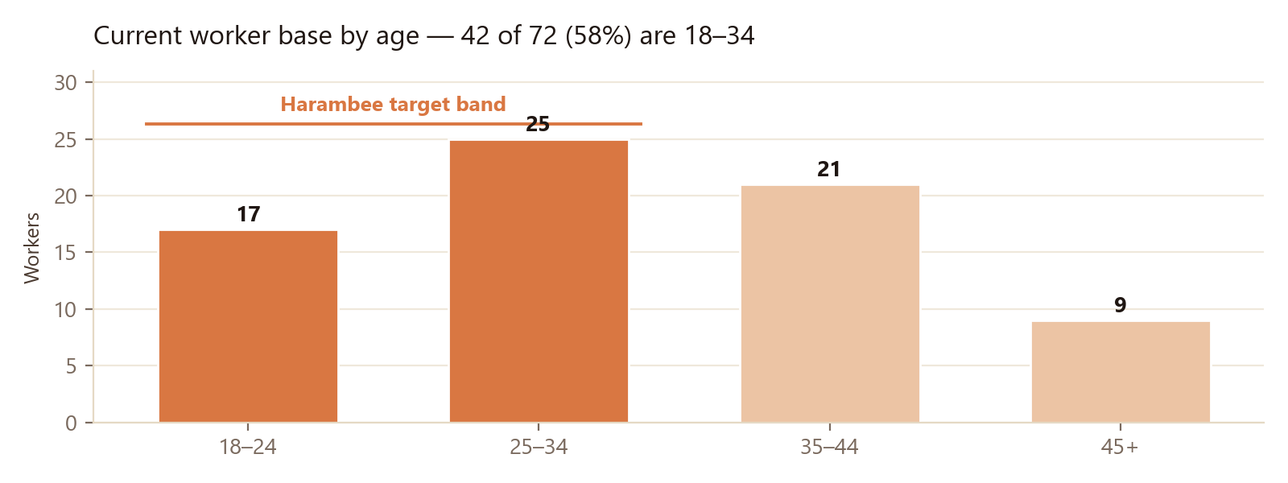

5. Recruitment channels
We recruit through five channels, weighted toward the ones that already work for us. Our current signup run-rate is 10–14 per day at effectively zero acquisition cost, which is why supply is not our constraint.
Channel | How it works | Share of intake
SAYouth.mobi listing | Workit listed as an earning opportunity; young people self-register via a tracked link so we can report placements back to Harambee | Target 40%
Community & partner organisations | Youth centres, churches, libraries, TVET colleges, community WhatsApp and Facebook groups — in-person onboarding sessions where we verify on the spot | 25%
Worker referrals | Existing workers refer friends; referrals are tracked on the profile and rewarded with free job boosts | 20%
Organic and social | Search, Facebook, WhatsApp status shares, word of mouth in serviced suburbs | 10%
Field activations | Taxi ranks, malls, spaza strips and community events in the specific suburbs where we have live employer demand | 5%
Deliberate sequencing: we open a channel in a suburb only once employers there are posting. Recruitment follows demand, never the reverse.

6. The onboarding funnel
Registration to first paid job is six stages. Target conversions are based on our live funnel to date, adjusted for the support we are adding.
Stage | What happens | Time | Target conversion
1. Register | Phone number or email; 18+ date-of-birth check; Terms and POPIA consent recorded | Under 3 min | 35% of reached
2. Profile | Name, photo, area, work categories and specific skills | 5 min | 70% of registered
3. Verify | SA ID number and ID document plus a selfie; automatic ID-format and duplicate-fraud checks; human review | Under 48 hrs | 60% of registered
4. Approve | Admin approves the account; automatic welcome guide emailed, with WhatsApp follow-up where needed | Same day | 95% of verified
5. Activate | Sets availability and receives push notifications for matching jobs nearby (WhatsApp alerts planned) | Immediate | 85% of approved
6. Earn | Accepts or counter-offers on a job, completes it, is rated and paid; payment confirmed by both sides | Within 30 days | 55–60% of verified
Where we intervene: stages 3 and 6 are where young people fall out. For stage 3 we run automated document reminders plus in-person verification days for those who struggle to photograph documents. For stage 6 — the one that matters — every young person who has not been hired within 21 days gets a personal follow-up, a profile review, and manual matching to the next suitable job.

7. Screening, safety and safeguarding
Young people are entering strangers' homes and premises, so safety is treated as a first-order product requirement, not a policy page:
- Identity verification. SA ID number validated for structure and cross-checked against date of birth and gender, ID document and selfie reviewed by a human, duplicate-ID and duplicate-document fraud detection across all accounts.
- Minimum age 18, enforced at registration by date-of-birth check.
- In-job safety toolkit. Emergency SOS with GPS capture that pages our safety team; optional live location sharing; a doorstep start code confirming the right worker at the right address; one-tap sharing of job details with a trusted family contact before the young person travels.
- Accountability on both sides. Two-way ratings, an employer trust panel shown before a worker accepts, blocking, reporting, a dispute process and content moderation.
- Data protection. POPIA-aligned: explicit consent captured for ID processing, sensitive data isolated with access restricted to two-factor-authenticated administrators, all document access logged, data export and deletion on request, retention limits enforced automatically. Data is hosted in the africa-south1 region.

8. Targets and phasing — 12 months, Gauteng
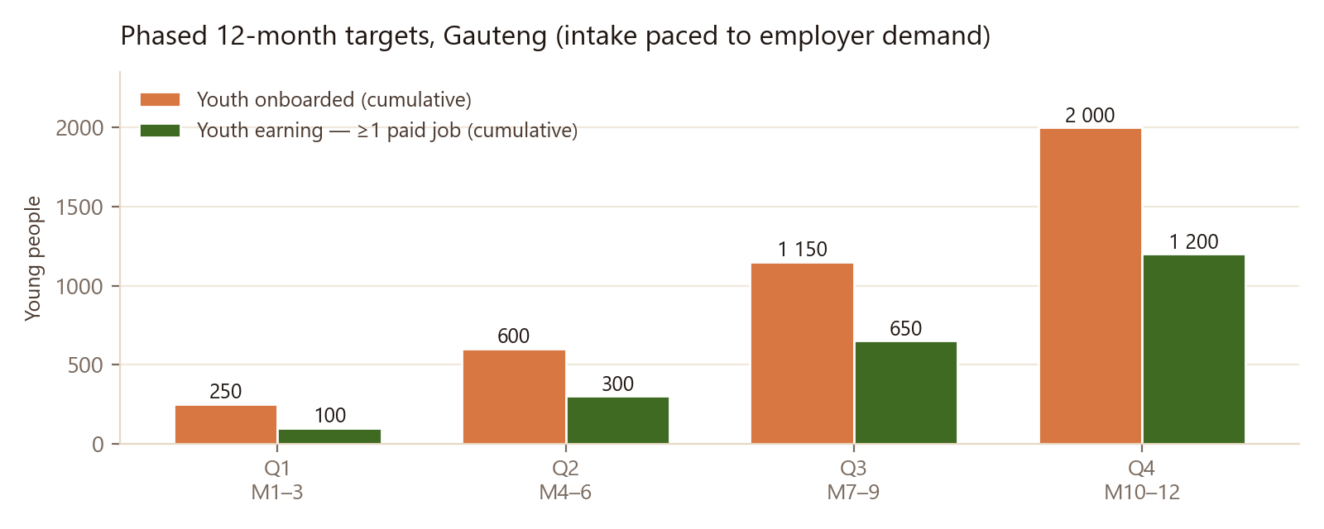
Quarter | Onboarded (cum.) | Verified (cum.) | Earning ≥1 job (cum.) | Jobs completed (cum.)
Q1 · M1–3 | 250 | 175 | 100 | 400
Q2 · M4–6 | 600 | 420 | 300 | 1 100
Q3 · M7–9 | 1 150 | 800 | 650 | 2 400
Q4 · M10–12 | 2 000 | 1 400 | 1 200 | 4 200
Estimated earnings into young people's hands: approximately R1.68 million over 12 months, at an average of R400 per completed job. Every rand goes directly from employer to worker — Workit takes no commission.

Geographic sequencing
We build density suburb by suburb rather than spreading thin — a young person must be able to reach the work, and employers must find workers close by:
- Q1: Soweto and Johannesburg South
- Q2: Tshwane — Mamelodi, Atteridgeville, Soshanguve
- Q3: Ekurhuleni — Tembisa, Katlehong, Vosloorus
- Q4: West Rand and Vaal — Kagiso, Sebokeng, Evaton

The demand side — what earns each intake wave
Because intake is paced to demand, these employer targets gate everything above: 150 active employers by end of Q1, 400 by Q2, 900 by Q3 and 1 600 by Q4. We reach them through direct business-to-business outreach in the same suburbs, property managers and body corporates (one contact generates recurring garden and cleaning work), estate agents, small businesses in high-density trading strips, and referrals from satisfied households. Introductions from Harambee's employer network would accelerate this materially — see Section 12.

9. Support after onboarding
- Written onboarding guide in plain language, sent automatically on approval, covering how to price a job, how to communicate with an employer, and what to do if something goes wrong.
- Skills and profile coaching. Workers who list specific skills and complete their profiles get significantly more offers; we prompt and assist with this directly.
- Human support. WhatsApp support line answered by our operations administrator, with same-day response as the standard.
- Work Record. Once a young person has completed jobs, they can generate and share a verified certificate of their work history and earnings at any time, free.
- Complementary training. We would welcome access to Harambee's work-readiness content to embed into our onboarding rather than duplicating it.

10. Measurement and reporting
Our administrative system already records everything below; we will report monthly in whatever format Harambee's monitoring team prefers, and can supply a live view:
- Young people registered, verified and approved — with source channel and SAYouth referral tracking
- Young people who completed at least one paid job (our primary success measure — not registrations)
- Jobs completed, total value paid to young people, and average earnings per active worker
- Demographic breakdown: age band, gender, suburb
- Retention: proportion still active at 30, 60 and 90 days
- Safety and dispute incidents, and how each was resolved

11. Risks and mitigations
Risk | Why it matters | Our mitigation
Insufficient employer demand (primary risk) | Young people who register and never get hired lose data, time and trust | Intake paced to demand; aggressive employer acquisition; personal follow-up for anyone unhired at 21 days; we would rather miss an onboarding target than strand a cohort
Data costs for young people | Airtime is a real barrier to job-seeking | Built as a low-data app; we are asking Harambee about zero-rating workitsa.co.za, as with SAYouth.mobi
Smartphone or ID access | Some young people have neither | Works on entry-level Android; in-person onboarding sessions; we assist with document capture but cannot substitute for a valid SA ID
Worker safety incident | Young people enter strangers' premises | Verification of both sides, SOS with GPS, start codes, trusted-contact sharing, live location, dispute and reporting systems
Underpricing / exploitation | Desperate workers may accept unfair rates | Workers set and counter-offer their own price; we publish indicative price guidance per category and never set a rate on the worker's behalf
Fraud and fake accounts | Undermines employer trust | Duplicate-ID and duplicate-document detection, human review, ban registry, moderation

12. What we are asking of Harambee / SAYouth
- List Workit as an earning opportunity on SAYouth.mobi, with a tracked referral link so placements are attributable and reportable.
- Employer-side introductions. This is our highest-value ask. Harambee's employer relationships — particularly property managers, facilities companies, retail groups and hospitality — would directly unlock the demand that our recruitment targets depend on.
- Zero-rating guidance for workitsa.co.za, so that reaching work costs a young person nothing in data.
- Access to work-readiness content we can embed in our onboarding flow.
- Feedback on this plan and on our reporting format, so our monitoring lines up with Harambee's placement definitions from day one.
- Consideration for relevant programmes or co-funding, where a youth-focused SA-owned platform fits the criteria.

Contact: Tshepo M, Founder · Furthersky Solutions · tshepowayne@workitsa.co.za · workitsa.co.za
We are glad to walk the Harambee team through the live platform and the administrative reporting view at any time, and to adjust targets, definitions or phasing to match Harambee's measurement framework.

